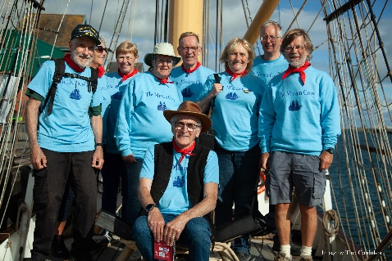
The Mizzen Crew is a Shanty Crew enjoying delivering songs, stories and music relating to life on the water. We share a passion for keeping traditions alive through entertainment and workshops.
We have a varied repertoire thanks to the contributions from each member of the crew who not only bring new ideas and material to our library but also are happy to lead the songs. We currently have 12 crew members which means we have a good chance of supporting all requests for performances.
We are happy to discuss your requirements and wherever possible, visit the venue prior to finalising our agreement to perform. We are a non-profit group, none of our members receive any remuneration for taking part except for extra ordinary expenses. At the end of the year, we do allocate our annual total fee paid between the running costs of the Mizzen Crew and the Morecambe RNLI.
Please can you fill in the details below to assist in our planning and response to your request.
Details of Person Authorised To Book Us To Perform:
Name:
Mobile No. Email address:

Event Details
Type of Event: Performance Shanty Workshop : Indoor Outdoor :
Can we advertise the event on our social media? Yes No
Can we bring a Fund Raiser Bucket for Morecambe RNLI? Yes No
Event Category: Festival Private Venue Charity Fund Raiser RNLI Fund Raiser Public Venue
Other (please explain)
Event Full Address & Post Code:

Event Website:
Event Date & Start & End Time :? When can we arrive on site? Date / Time:
What are the car parking arrangements:
Please describe any available refreshments:
Please describe the PA being provided: (Number & type of mics and mic stands, etc)

What is the set-up time for PA & mic checks?
Please give as much details as possible about your requirements for our performance (e.g. timings of sets.)

Please attach an event image / logo (default will be Mizzen Crew logo)
Details of Person / Organisation Paying Invoice: (please state If no fee /reimbursement is agreed)
Invoices are due in 10 days unless stated otherwise on this form.
General guideline on fees:
- If the event is for a registered charity or community fund raising (for instance the RNLI) then we do not expect a fee.
- we will need to agree a fee if the event is (a) in a commercial venue such as a pub, (b) is a funded event or (c) if other acts are paid for their performance,
- offers of reimbursement of travel costs are welcomed.
Offered Fee: £
Offered Reimbursement: £
Name:
Mobile No. Email address:
Person / Organisation Address:

Please provide charity name and registration number if appropriate:

